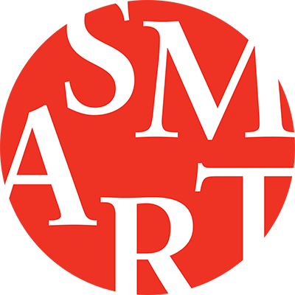

The University of Chicago Invites Applications for
the Dana Feitler Director of the Smart Museum of Art

The Smart Museum is a university art museum that supports field-defining research and teaching of faculty and students; annually presents several dynamic, often path-breaking exhibitions; and offers distinctive public programs that convey the significance of the visual arts across periods and cultures. Through its impressive collection and its intensive collaboration with scholars, the Smart has established itself as a driving force for thinking creatively about the history and exhibition of artworks, and thus contributes to Chicago’s status as one the premiere art capitals of the world.

As the chief executive of the Smart Museum, the Dana Feitler Director will promote and support education and scholarship of the highest caliber in the visual arts, and define the Smart’s position as a leader in the museum field as well as in research and education in the visual arts. The Director is responsible for providing overall leadership, vision, and guidance to the Museum and its staff. S/he is charged with ensuring that the Museum remains a vibrant and active institution in the local community and regularly engages with its peers nationally and globally. The Director serves as the principal ambassador for the Museum to students and faculty, other influential members of the campus community, the Governing Board and UAC, alumni and major supporters, as well as the larger public. The Director is the key driver in creating a cohesive and effective organization and staff, fostering teamwork, and creating an environment in which all staff members work together effectively and efficiently in order to meet institutional goals.

The Smart Museum of Art’s next Director will be a persuasive and inventive leader who is inspired by the Museum’s mission and can inspire others as well. S/he should possess the intellectual vigor and vision, as well as the sterling reputation and personal magnetism that are necessary to encourage trust and to galvanize support for the Museum. The successful candidate will be a strategic and energetic leader who is collaborative, diplomatic, and inspires confidence. S/he must have seven to ten years of leadership experience in an art museum setting. An advanced degree in an art-related field required; a PhD is a plus, as is equivalent professional and leadership experience in a comparable setting.

This is an exciting opportunity to lead a unique institution into its next chapter with the strong commitment of the University and the Museum’s Board of Governors. The next Director will play a powerful role in helping to shape a thriving arts culture on campus and to augment that culture’s outward engagement with the prominent arts scene in Chicago’s South Side and in the city at large.

The Smart Museum of Art, The University of Chicago has retained the executive search firm of Korn Ferry to assist in the search. Please email nominations and applications (resume and cover letter) to: Naree W.S. Viner, Principal, at SmartDirector@kornferry.com.

All qualified applicants will receive consideration for employment without regard to race, color, religion, sex, sexual orientation, gender identity, national origin, age, protected veteran status or status as an individual with disability. The University of Chicago is an Affirmative Action / Equal Opportunity / Disabled / Veterans Employer. Job seekers in need of a reasonable accommodation to complete the application process may contact Somaiyya Ahmad by calling 773.702.9798 or by emailing somaiyya@uchicago.edu with their request.

The Search Committee will begin reviewing candidates in late February and will continue to review applicants until the position is filled.

