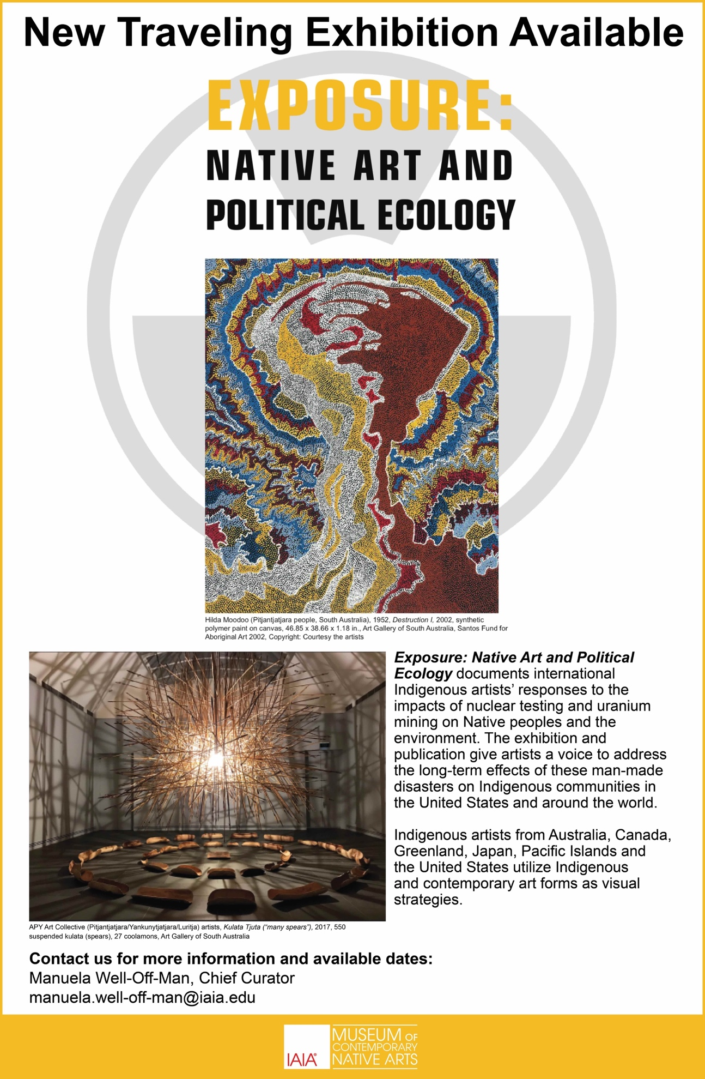

Traveling Exhibitions
IAIA Museum of Contemporary Native Arts’ (MoCMA) traveling exhibition program offers thought-provoking, engaging exhibitions featuring works by leading artists and addressing current issues.

Exposure: Native Art and Political Ecology
Exposure: Native Art and Political Ecology documents international Indigenous artists’ responses to the impacts of nuclear testing, nuclear accidents, and uranium mining on Native peoples and the environment. The traveling exhibition and catalog give artists a voice to address the long-term effects of these man-made disasters on Indigenous communities in the United States and around the world. Indigenous artists from Australia, Canada, Greenland, Japan, Pacific Islands, and the United States utilize local and tribal knowledge, as well as Indigenous and contemporary art forms as visual strategies for their thought-provoking artworks.
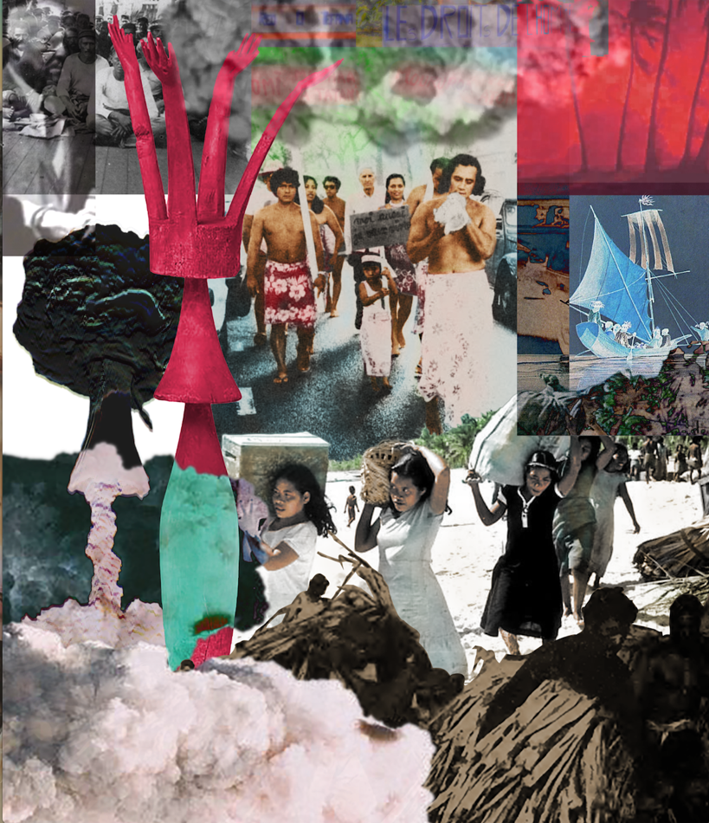
Dan Taulapapa McMullin (Samoa), Te Mau Ata: Clouds, 2021
Photo-collage, acrylic on canvas, 42 x 36 in.

Exhibition Size and Availability
The exhibition size is 365 linear feet (2127 square feet) and it is available for booking periods beginning March 1, 2022. (The exhibition size is negotiable.)
- August 13, 2021–January 23, 2022: IAIA Museum of Contemporary Native Arts )
- March–May, 2022: Available
- July–September, 2022: Available

Provided with the Exhibition
- Approximately 45 works of art
- Didactics: wall panels (section panels) and object labels, digital labels with information on featured artists, and an audio tour (MP3 file format)
- A set of images for public relations, advertising, web, and educational uses, and five (5) complimentary copies of the accompanying exhibition catalog (additional copies available)
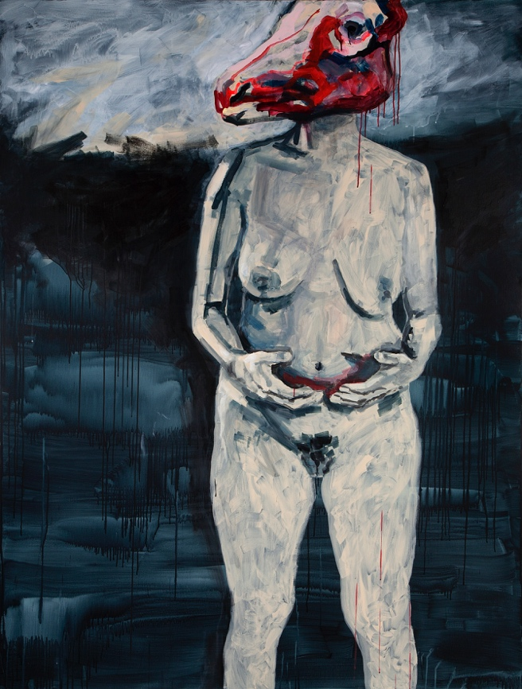
Bolatta Silis-Høegh (Inuit), Outside, (self-portrait from her Lights On, Lights Off series)
Ca. 2015, acrylic on canvas, 82.7 x 63 x 5.9 in.
Greenland National Museum, Nuuk, GL

Exhibition Requirements
- Wall-to-wall Fine Arts insurance and certificate of insurance
- Pedestals for sculptures, with or without vitrines as required by MoCNA
- Trained art handlers for installation and de-installation
- Standard facilities report
- 24-hour security surveillance, and security guards when the exhibition is open to the public
- Temperature and humidity controls
- Dimmable lighting is required and works may not be exposed to direct sunlight
- Members of the public may take photographs or make videos for personal, non-professional use without flash, tripod, or selfie-stick
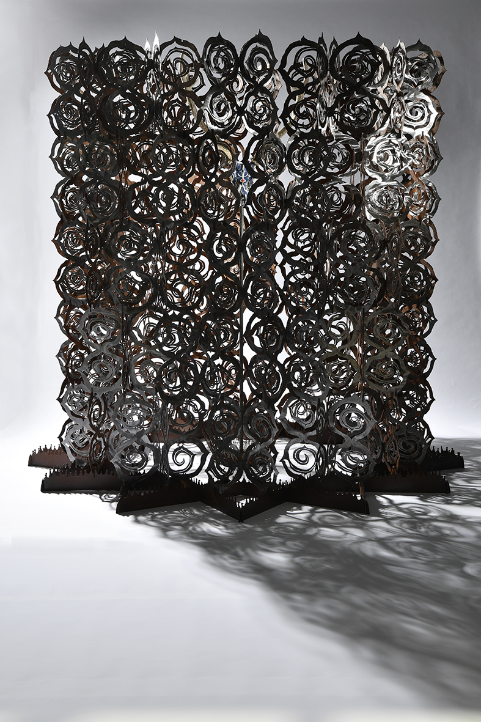
Kohei Fujito (Ainu), Siw-siw-atki kor-ram ka oray-oray kipip-kipip (The Singing of the Needle)
2020, Iron, acrylic, and deer skull, height 6.9 ft (2.1m); outer diameter 6.2 ft

Shipping
- Shipping Cost: Exhibitor pays for incoming shipping
- Exhibition Fee: $15,000 (negotiable)

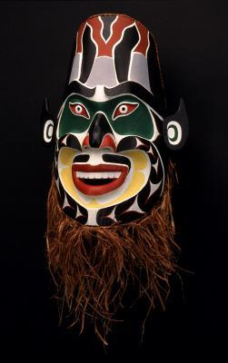
David Neel (Kwakwaka'wakw, Canada, British Columbia)
Chernobyl Mask (Allusion to Bakwas , (Nuclear Disaster Mask), 1993
Cedar wood, cedar bark, acrylic paint, 28 x 14 x 8 in.,
Margaret E. Fuller Purchase Fund, 97.55, Seattle Art Museum

Contact
To inquire further about the availability of Exposure: Native Art and Political Ecology or to receive a prospectus and checklist for this traveling exhibition, contact IAIA Museum of Contemporary Native Arts (MoCNA) Chief Curator Manuela Well-Off-Man at manuela.well-off-man@iaia.edu.

